**The Gray Area Project**

**Expanding Our**

**Understanding of Good vs. Evil**

**By: Matt Turner, Ryan Plantz**

**Learning Objective:** In this project students will expand their understanding of good vs. evil through the context of storytelling and Star Wars. After completing the ethical code activity students will be tasked with determining why a machine that has a strict ethical code could be dangerous. In this project students will discover a new ethical view that, if encoded into a machine, could pose less of a danger and even dramatically benefit society.

**Introduction:**  Artificial Intelligence continues to reflect the ethics of humanity through bias, deception, inequality, and privacy. Without a firm understanding of what our ethical code should be we run the risk of creating A.I. systems that make inappropriate decisions that negatively affect human lives. A.I. is now assisting in deciding who goes to jail, gets into college, gets a job, and more. Creating an ethical code that is more humane, complex, and deeper than the splitting of good vs. evil may help solve this problem. A code of ethics known as virtue ethics looks at the complex nature of human character instead of the simplistic notion of right and wrong. Another code that follows this same theme is the Gray Jedi Code from the Star Wars universe. A fun way to get students engaged in this material is to talk about who the Gray Jedi are.

**Concepts to Be Addressed:**

* Fiction vs. Non-fiction storytelling
* Storytelling tips & tricks
* Good becoming Evil
* Evil becoming Good
* A.I. Reflects Human Ethics
* The “Gray Code” (Star Wars)
* Virtue Ethics (Real Life)

**Criteria for Success:**

* One long story or three short stories, fiction or nonfiction
* Incorporates a main theme of:
  + good→ evil
  + evil→ good
  + neutral → good or bad
* No word or page limit, but your story should include:
  + Introduce your characters
  + A problem or dilemma
  + A turning point or climax
  + A resolution or conclusion
* A reflection explaining how your story connects to A.I.
  + Are people only evil? Only good?
  + How might a machine react to your characters?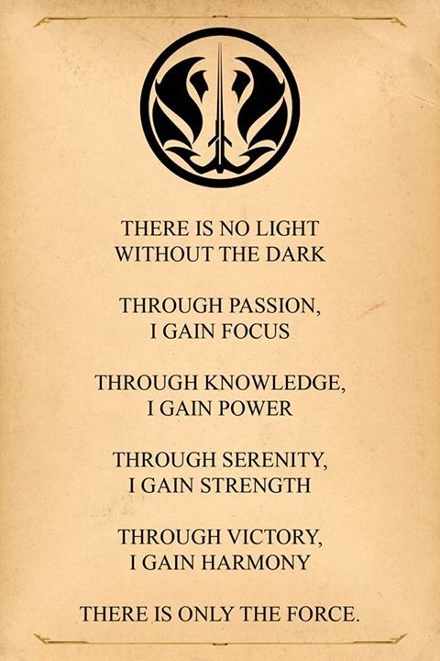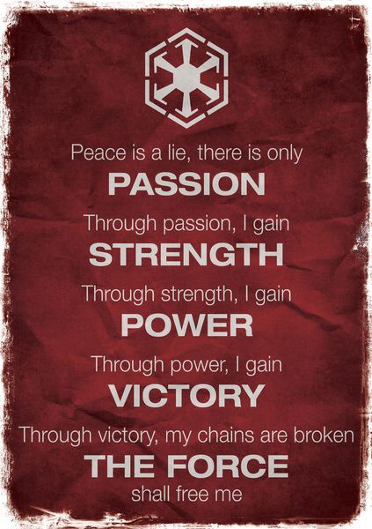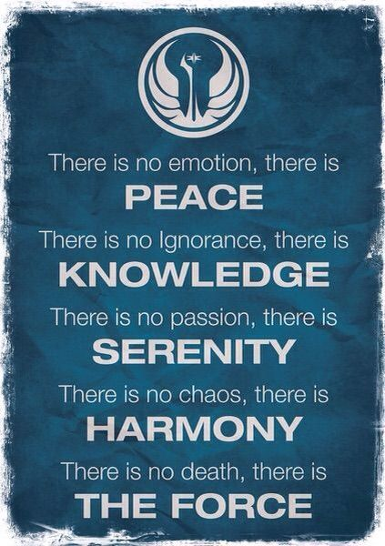

**Discussion Questions:**

1. If a machine was coded using the Jedi Code what might happen? What might happen to people who are ignorant?
2. If a machine was coded using the Sith Code what might happen?
3. If a machine was coded using the Gray Code what might happen?
4. Would you want a machine to have your original ethical code? Why or why not?
5. If you could create a new ethical code for a machine what would it look like? Would it look similar to the Sith, Gray, or Jedi code?

Sith “Evil” Code Gray Jedi Code Jedi “Good” Code